Wearable Alarm System for the Deaf Using Sound and Temperature Detection
Emily D. Delgado Gonzalez
¹Florida International University, Biomedical Engineering Department, 10555 W Flagler St, Miami, FL 33174

Wearable sensing technologies have become increasingly prevalent in modern healthcare and safety applications. Devices such as smartwatches, fitness trackers, and smart rings continuously monitor physiological and environmental parameters and provide real-time feedback to users. These systems enable continuous monitoring outside of traditional clinical settings and are particularly valuable for safety-critical applications (Mirjalali et al., 2021).
For individuals who are deaf or hard of hearing, conventional auditory alarms such as smoke detectors or fire alarms may not provide adequate warning during emergencies, particularly at night. As a result, alternative alert mechanisms that rely on visual or vibration-based feedback are necessary. Previous studies have demonstrated that wearable devices capable of detecting environmental sounds and providing non-auditory alerts can significantly improve situational awareness and safety for deaf users (Yağanoğlu, 2018).
In fire-related emergencies, relying on a single sensing modality may result in false positives or missed detections. Combining multiple environmental signals, such as sound and temperature, can improve robustness and reduce erroneous alerts. Organizations such as the National Fire Protection Association emphasize the importance of multimodal alarm technologies, including visual and tactile alerts, for deaf and hard-of-hearing populations (National Fire Protection Association, 2021).
The objective of this project was to design and implement a simplified wearable alarm system capable of detecting dangerous nighttime fire conditions by simultaneously monitoring sound and temperature. When both parameters exceeded predefined thresholds, the system activated a vibration-based buzzer and LED alert integrated into a wearable band. MATLAB and an Arduino microcontroller were used to acquire sensor data, implement detection logic, and demonstrate system functionality.
2. Materials and Methods
2.1 Hardware & Circuit Setup
The wearable alarm consists of a short set of components:
- Arduino Leonardo microcontroller
- Disc piezoelectric
- Strain gauge temp proxy with an LM358 amplifier
- Passive buzzer
- Light Emitting Diode (LED
- Resistors, jumper wires
- A breadboard
- A wearable band enclosure
The piezo disc is connected to the Arduino analog input A0 to detect changes in sound intensity. The substitute for temperature, which consists of a strain gauge and an LM358 amplifier, is connected to analog input A1 to simulate environmental temperatures. The LED is attached to digital pin D9, and the buzzer is connected to digital pin D3. They all share common grounds and power sources. A circuit diagram and a picture of the wearable device will be shown in the results.

Figure 1. Overview of wearable alarm system-off-wrist
This shot shows the entire wearable alarm system assembled and powered. The sound sensor is a piezo disc mounted on a watch band to keep the device visibly wearable. An Arduino Leonardo, with its support circuitry on a breadboard, is wired up for testing. The whole setup is linked up to a computer via USB for both power and MATLAB-based analysis. This configuration allowed functional checks before the device was worn on the wrist.
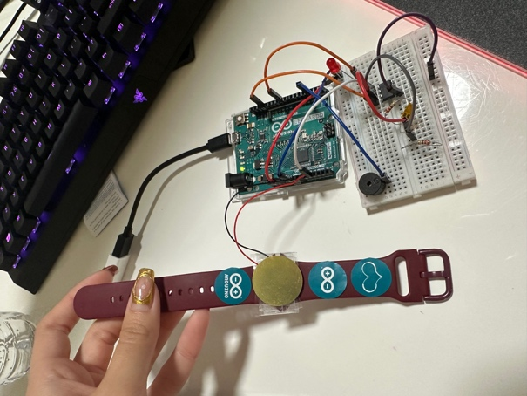
_
Figure 2: Wearable alarm system on the wrist
Here you can see the system in use. The piezo disc is on the watch band and rests against the skin, showing how the device would be in contact with the wearer during sleep. The breadboard and Arduino remain externally connected. This image shows how such sensors can be integrated into a wearable to alert a deaf or hard-of-hearing person.
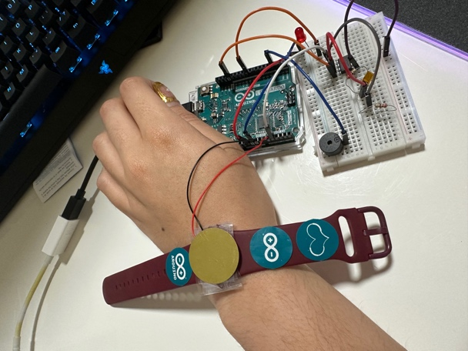
Figure 3. Alarm circuitry using a breadboard
A close-up on the breadboard shows, in detail, the various components of the project: a passive buzzer for vibration alert, an LED for light alert, the resistor, and the connectivity with an Arduino Leonardo. The breadboard here represents a prototype stage before miniaturization and is able to accommodate multiple sensors and outputs.
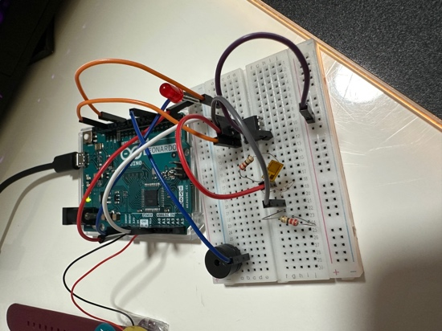
-
Figure 4. Full system setup
This figure illustrates the complete setup with an Arduino, sensors, and a wearable band.
Here is a complete setup image including Arduino Leonardo, breadboard circuitry and a sound sensor and wearable device:
This is the photo showing all parts in one setting: Arduino Leonardo, breadboard connections, the sound sensor, and the wearable band. This will then specify how it is that the wiring of electricity will connect the components to the wearable as an end device, detached from the control hardware.
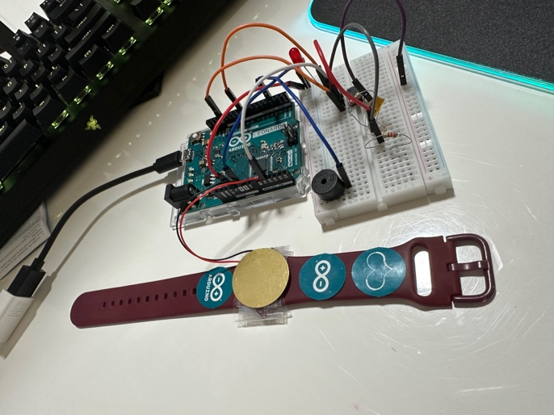

2.2 Data Acquisition and Experimental Procedure
Data acquisition

The data acquisition and control in this case are facilitated by using the MATLAB platform with the Arduino Support Package. The two analog sensors are polled in real time. To avoid false triggering based on sensor drift, the system undergoes a baseline calibration when a new trial begins. Baseline measurements are used to set a standard voltage level based on each sensor without an external input.
After that, it continually monitors deviations from these thresholds. A danger state is marked when both deviations in sound and temperature go beyond their thresholds. The alarm, comprising an LED light and a buzzer, sounds when both thresholds are attained. Simulation of a danger state is achieved when a hair dryer is placed to excite both sound and temperature sensors; a safe state can only be achieved when the heating source is turned off and allowed to cool. The system runs uninterruptedly for five minutes.
2.3 Detection Rules and Alarm Logic
The thresholds were empirically set based on responses to stimulation and baseline sensor activity. The rules are:

- No Danger State: sound deviation below threshold or temperature deviation below threshold.
- Danger State: both sound & temp deviations beyond thresholds.

When it finds any danger, the LED light turns on and the vibration alarm starts sounding. Once each parameter gets back to normal, such as when the cooling starts removing the heat, the alarm immediately turns off.
3. Results
Figure 5. Shows a graphical representation of the sound wave recorded over time with the baseline and threshold indicated. The sudden jump in sound amplitude occurred during alarm simulations.
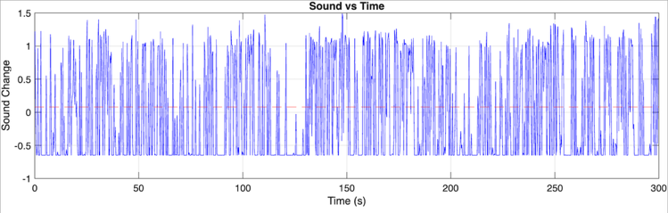
Figure 6. Shows a representation of how the temperature sensor responded by increasing with exposure to heat and returning to baseline when cooled.
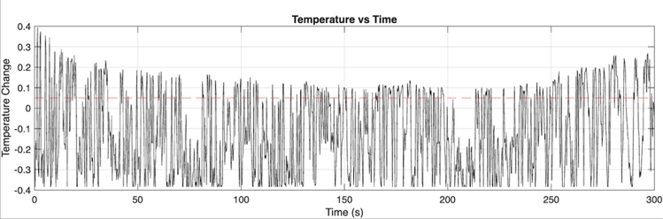
The system was capable of identifying two states:
- Safe state
- Danger state.
Activation of the alarm occurred when both sound and temperature thresholds were violated simultaneously. During a five-minute recording time, phases of alarm activation and deactivation occurred in accordance with the application and removal of sound and temperature stimuli.
A video illustrating a real-time acquisition of data, circuit function, and alarm output is offered with the submission.
4. Discussion
The wearable alarm system successfully demonstrated dual-sensor detection using sound and temperature inputs, reducing false alarms compared to single-sensor approaches. This multimodal strategy aligns with prior work showing that combining environmental cues improves reliability in wearable alert systems for deaf users (Yağanoğlu, 2018). The use of vibration-based and visual feedback is consistent with recommendations for alarm technologies intended for deaf and hard-of-hearing populations (National Fire Protection Association, 2021).
While the prototype effectively demonstrated the intended functionality, several limitations were observed. The temperature sensing approach relied on a strain-gauge-based proxy rather than a dedicated temperature sensor, resulting in slower thermal response and increased susceptibility to environmental noise. Commercial wearable devices typically integrate dedicated temperature sensors, optimized embedded firmware, and low-power microcontrollers to improve accuracy, response time, and autonomy (Mirjalali et al., 2021). Future iterations of this design could incorporate these features to more closely resemble commercial wearable safety devices.

References
- Yağanoğlu, M. (2018). Real-Time Detection of Important Sounds with a Wearable Device. Electronics, 7(4), 50. https://www.mdpi.com/2079-9292/7/4/50
- Mirjalali, S., et al. (2021). Wearable Sensors for Remote Health Monitoring. PMC. https://www.ncbi.nlm.nih.gov/pmc/articles/PMC8646515/
- National Fire Protection Association. (2021). Review of Alarm Technologies for Deaf and Hard of Hearing Populations. https://www.nfpa.org/education-and-research/research/fire-protection-research-foundation/projects-and-reports/review-of-alarm-technologies-for-deaf-and-hard-of-hearing-populations

